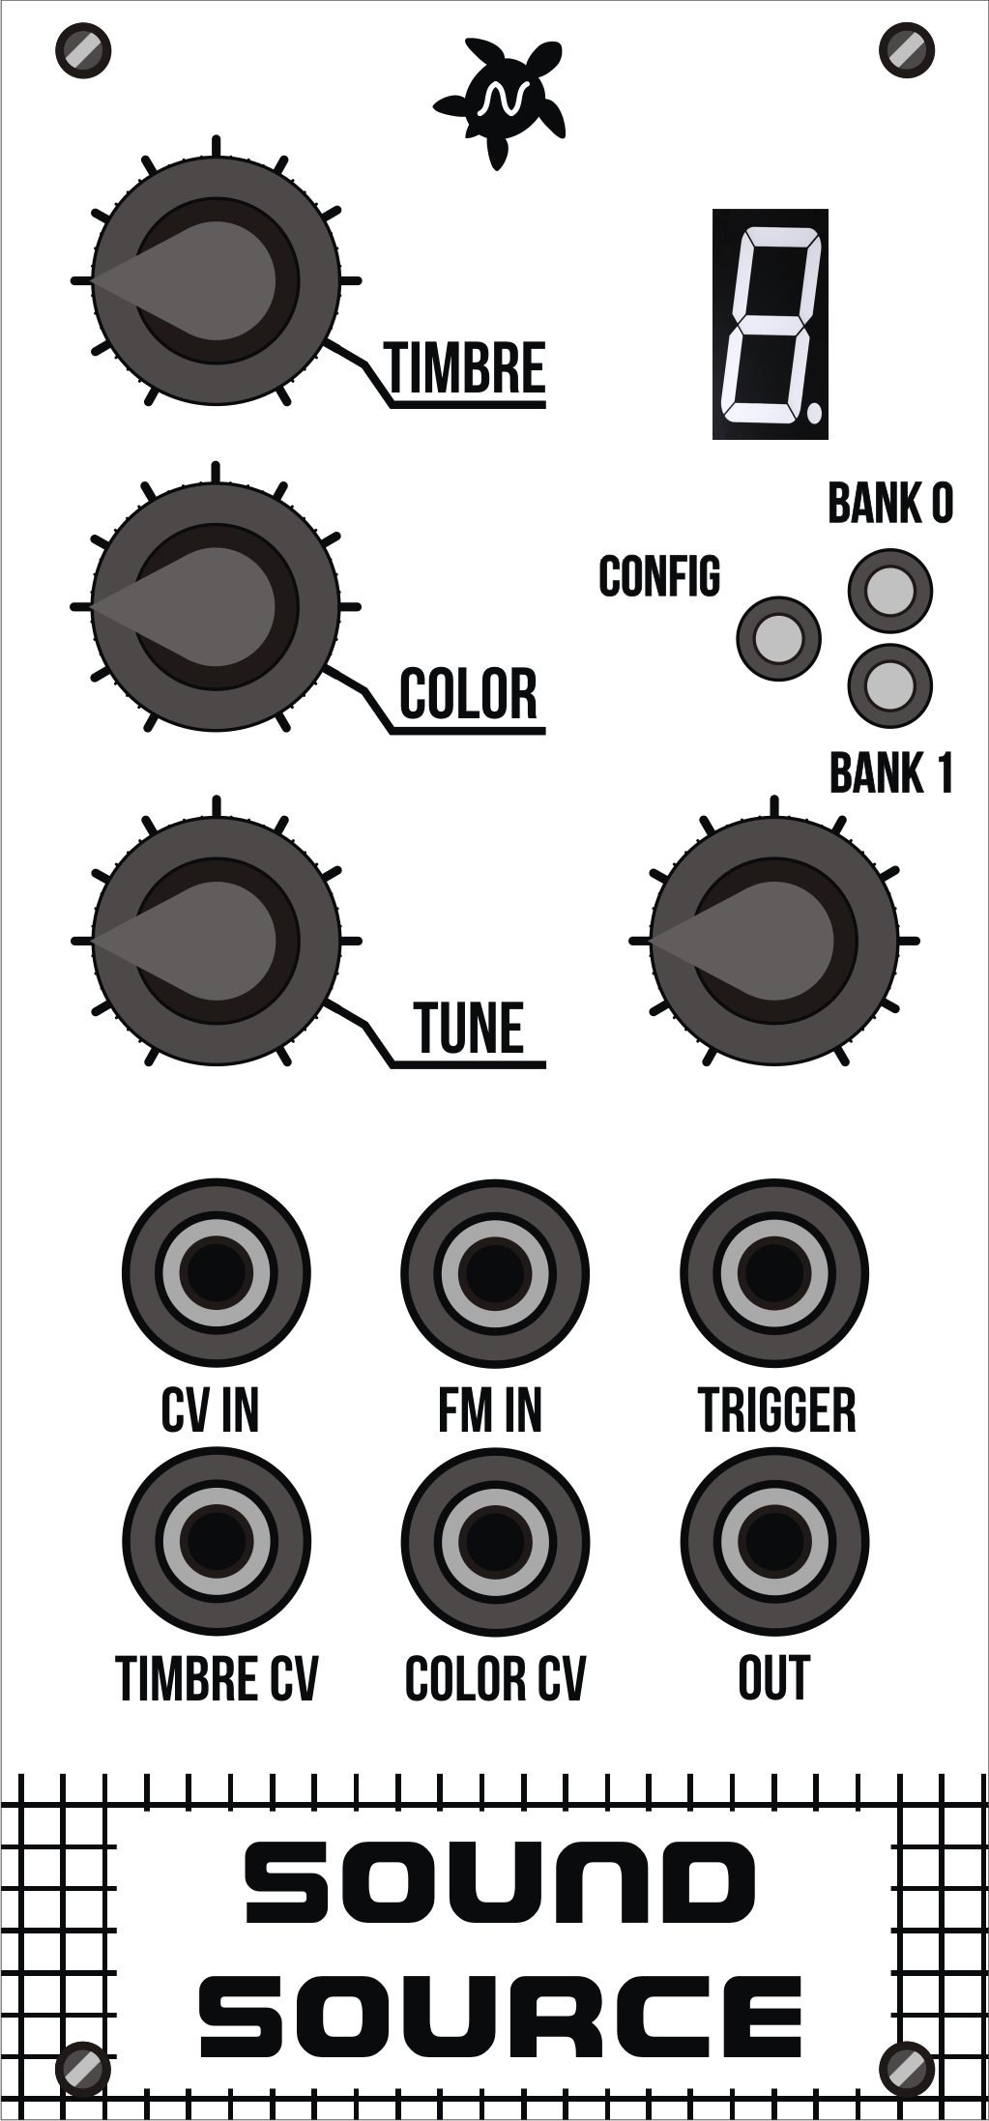

**User’s**

**MANUAL**

*SOUND SOURCE*

September 2020

**Revision Sheet**

|  |  |  |
| --- | --- | --- |
| **Release No.** | **Date** | **Revision Description** |
| Rev. 0 | 13/09/2020 | User’s Manual First revision |
|  |  |  |
|  |  |  |
|  |  |  |
|  |  |  |
|  |  |  |
|  |  |  |

**USER'S MANUAL**

**TABLE OF CONTENTS**

Page #

A. GENERAL INFORMATION 1

​ 1.1 Specifications 1

​ 1.2 Description 2

B. GETTING STARTED 1

​ 2.1 Overview 1

​ 2.2 Usage 2

​ 2.3 Configuration 4

​ Enter configuration mode 4

​ CALIBRATION 5

**1.0 GENERAL INFORMATION**

# GENERAL INFORMATION

## 1.1 Specifications

* Format: Eurorack
* Dimensions: 12HP, 80mm deep
* Internal and external signals: 0-5V Logic I/O
* Max Current:
  1. +12V: 100mA
  2. -12V: 1mA
  3. +5V: n/a

## 1.2 Description

Sound Source is a voltage-controlled monophonic digital sound source. Each algorithm is controlled by two continuously variable parameters, TIMBRE and COLOR, both of them voltage controllable. Instead of being directly assigned to the intricate details of the synthesis algorithm, they work as meta-parameters going through all the sweet spots. Very often, these parameters simultaneously affect several dimensions of timbre, creating very complex movements which would be hard to generate with a traditional setup.

This project is based on Mutable Intruments “Braids” <https://mutable-instruments.net/modules/braids>

Features

* 43 Waveforms
* Quantizer on the CV-input with a large selection of scales.
* Analog VCO-style linear detuning of higher frequencies.
* Built-in AD envelope, assignable to the oscillator frequency, the COLOR and TIMBRE parameters, and to the amplitude.
* META mode enabling CV-controlled model selection with the FM input.
* 12-bit CV capture.
* 96kHz, 8-bit audio processing (some algorithms are 2x or 4x oversampled).
* Waveforms
  + CS-80 style sawtooth with a notch.
  + Continuously variable morphing between triangle, sawtooth, square and pulse, with character control.
  + Square/sawtooth with pulse width control.
  + Triangle to sine morphing, with wavefolder.
  + Band-limited dual pulse train, with detuning.
  + Dual square or sawtooth oscillator with hard sync.
  + Triple saw, square, triangle or sine.
  + Stack of three ring-modulated sine waves.
  + Swarm of seven sawtooth waves.
  + Comb-filtered sawtooth wave
  + Circuit-bent sawtooth generator with sample rate reduction and bit toggling.
  + Direct synthesis of filtered waveforms, casio CZ style.
  + Low-fi or hi-fi vowel/formant synthesis.
  + Harmonic oscillator.
  + FM with various feedback paths.
  + Plucked string (Karplus Strong).
  + Bowed string.
  + Reed and flute.
  + Bell and metallic drum.
  + 808 bass drum, cymbal noise and snare drum.
  + Noise processed by a tuned multimode filter.
  + Noise processed by a dual BP filter.
  + Clocked digital noise.
  + Cloud of sinusoidal grains.
  + Particle synthesis.

**2.0 GETTING STARTED**

# GETTING STARTED

## 2.1 Overview

**Display:**Show the current waveform.



**TIMBRE:**This parameter controls the main evolution and motion of the timbre.

**Leds:**Indicate current

bank of waveforms. Config led is on in configuration mode.

**COLOR:**This knob controls a second dimension of sound.

**Encoder:**

Use this encoder to set the current waveform and enter into config mode.

**CV IN:**1V/Oct frequency CV input.

**TUNE:**Fine frequency control.

**TRIGGER INPUT:**

Triggers the internal AD module and oscillator.

**FM IN:**

Frequency modulation CV input. Positive only.

**TIMBRE & COLOR CV INPUTS:**

Control voltages for the Timbre and Color parameters.

**Timbre & Color inputs:** Control voltages for the Timbre and Color parameters. A value of 0V corresponds to the maximum position of the knob. A value of +5V corresponds to the minimum position of the knob. This CV is offset by the current position of the knob.

**Trigger Input:** This trigger input serves three purposes. 1) Physical models need to be “excited” by an impulse on this input to give birth to a sound. 2) The other models will treat the trigger as a reset signal, bringing the phase of the oscillator(s) to 0. 3) This input can also be used to trigger an internal AD envelope applied to the parameters of your choice, to create sound animation and attacks without an external envelope module.

**OUT:** Signal output. Loudness is model-dependent - for example a pure sine wave is always at maximum amplitude; while a ring-modulated sine-wave will have peaks and valleys due to amplitude modulation, and will thus sound quieter.

## 2.2 **Usage**

**Encoder:** Move the encoder to select a waveform. The config led will turn on. Then click the encoder to activate the selected waveform. The config led will turn off.

Waveforms for Bank 0

|  |  |
| --- | --- |
| **Code** | **Waveform** |
| **0** | CSAW |
| **1** | MORPH |
| **2** | SAW_SQUARE |
| **3** | SINE_TRIANGLE |
| **4** | BUZZ |
| **5** | SQUARE_SUB |
| **6** | SAW_SUB |
| **7** | SQUARE_SYNC |
| **8** | SAW_SYNC |
| **9** | TRIPLE_SAW |
| **A** | TRIPLE_SQUARE |
| **B** | TRIPLE_TRIANGLE |
| **C** | TRIPLE_SINE |
| **D** | RING_MOD |
| **E** | SAW_SWARM |
| **F** | SAW_COMB |
| **G** | TOY |
| **H** | DIGITAL_FILTER_LP |
| **I** | DIGITAL_FILTER_PK |
| **J** | DIGITAL_FILTER_BP |

Waveforms for Bank 1

|  |  |
| --- | --- |
| **Code** | **Waveform** |
| **0** | DIGITAL_FILTER_HP |
| **1** | VOSIM |
| **2** | VOWEL |
| **3** | VOWEL_FOF |
| **4** | HARMONICS |
| **5** | FM |
| **6** | FEEDBACK_FM |
| **7** | CHAOTIC_FEEDBACK_FM |
| **8** | PLUCKED |
| **9** | BOWED |
| **A** | BLOWN |
| **B** | FLUTED |
| **C** | STRUCK_BELL |
| **D** | STRUCK_DRUM |
| **E** | KICK |
| **F** | CYMBAL |
| **G** | SNARE |
| **H** | FILTERED_NOISE |
| **I** | TWIN_PEAKS_NOISE |
| **J** | CLOCKED_NOISE |
| **L** | GRANULAR_CLOUD |
| **O** | PARTICLE_NOISE |
| **P** | DIGITAL_MODULATION |

**TUNE:** Move Tune knob to right or left to detune the oscillator. The dot in the display will show the current state is “detuned”. Move it to the center to set to calibrated frequency again.



**Dot On: Uncalibrated**

**Dot Off: Calibrated.**

## 2.3 **Configuration**

### **Enter configuration mode**

Click the encoder for 5 seconds. Config led will turn on and both bank leds will turn off. The display will show a “A”. Move the encoder to select a setting.

Settings table

|  |  |
| --- | --- |
| **Code** | **Setting** |
| **A** | **ATTACK.** Attack time of the internal AD envelope generator. |
| **D** | **DECAY.** Decay time of the internal AD envelope generator. |
| **F** | **FM.** Control the amount of modulation from the internal AD envelope generator to the FM. |
| **T** | **TIMBRE.** Control the amount of modulation from the internal AD envelope generator to the Timbre. |
| **C** | **COLOR.** Control the amount of modulation from the internal AD envelope generator to the Color. |
| **H** | **VCA.** Control the amount of modulation from the internal AD envelope generator to Output Amplitude Parameters |
| **E** | **META MODULATION.** Allows the synthesis model to be selected by the FM CV. When this mode is active, frequency modulation through the FM CV input is no longer possible.  0: Off  1: On |
| **G** | **TRIGGER.** Selects a trigger source.  0: INTERNAL. Trigger Input jack will be used.  1: AUTO additionally tracks changes in the V/OCT frequency input larger than a semitone and generates a trigger on each of these. |
| **U** | **QUANTIFICATION.** Applies a quantification to the incoming V/OCT control voltage. The frequency can be quantized to semitones, or to one of the many available scales, or disabled.  0: Off  1: SEMI  2: IONI  3: DORI  4: PHRY  5: LYDI  6: MIXO  7:AEOL  8:LOCR  9:BLUES+  A:BLUES-  B: PEN+  C:PEN-  D: FOLK  E:JAPA  F:GAME  G:GYPS  H:ARAB  I: FLAM  J:WHOL |
| **R** | **ROOT.** Selects the root note upon which is built the quantizer’s scale.  0: C  1: Db  2: D  3: Eb  4: E  5: F  6: Gb  7: G  8: Ab  9: A  10: Bb  11: B |
| **L** | **FLAT.** Applies a detuning in the lower and higher frequencies, to recreate some of the tuning imperfections of VCOs. |

After select a setting, click the encoder once. The current setting’s value will be shown. Use the encoder to change the value. Click the encoder once to return to the settings menu.

To go back to waveform selection, click the encoder for 5 seconds.

### **CALIBRATION**

To calibrate the unit, in settings mode, click the encoder 8 times. All leds will turn on and the display will show “2”.

Disconnect any signal from the FM input, and connect the note CV output of a well-calibrated keyboard interface or MIDI-CV converter to the V/OCT input. Turn TUNE knob to 12 o’clock position and TIMBRE and COLOR knobs to the right.

Send a voltage tha corresponds to C2 to the CV input. Click on the encoder.

The screen displays “4”. Send a voltage that corresponds to C4 to the CV input. Turn TIMBRE and COLOR knobs to the left.

Click on the encoder to finish calibration.